**Flowchart**

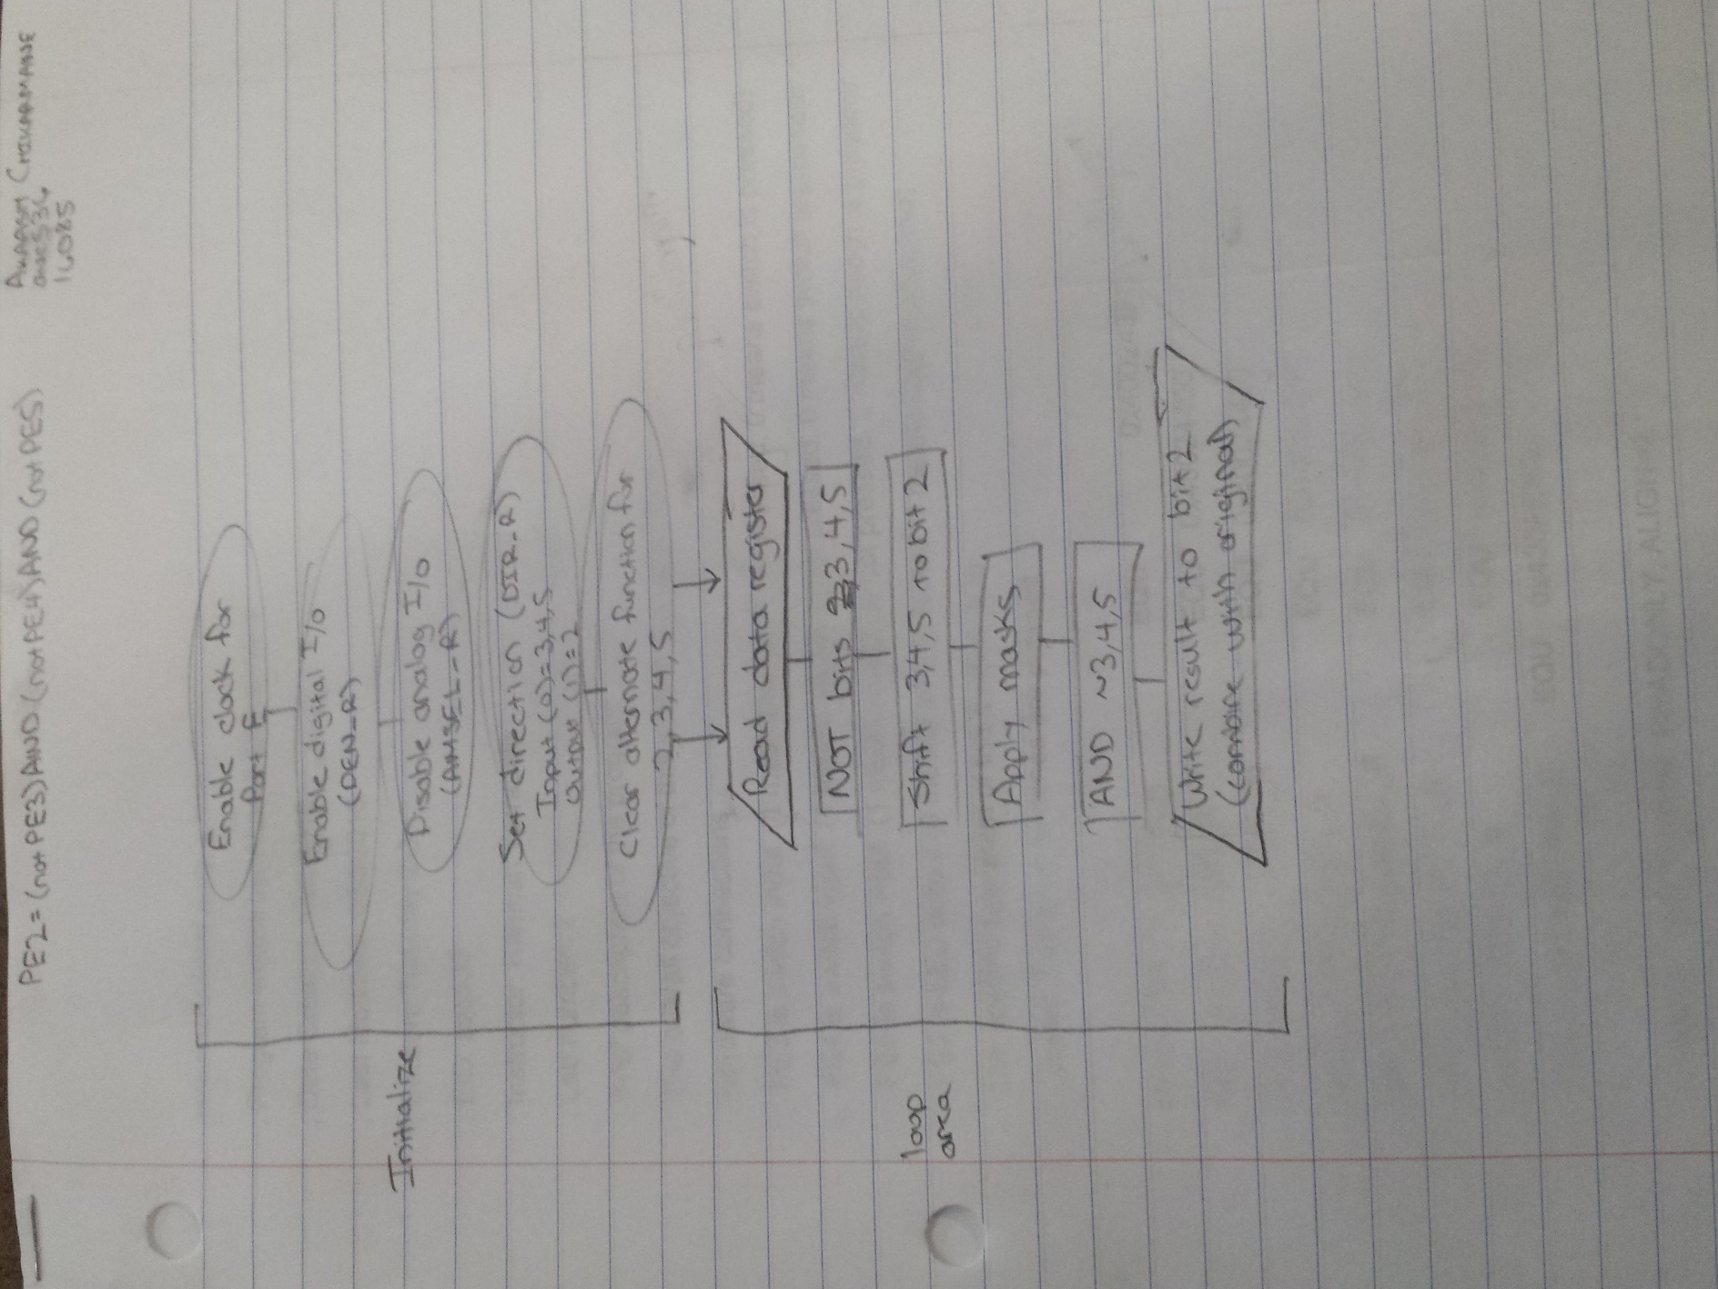

**Pseudo-Code**

;R0 = clock

;read clock into R1

;turn on clock E (0001 0000)

;write back in

;stabilize clock

;enable digital I/O

;digital for 2,3,4,5 (0011 1100)

;disable analog I/O (not alternate functions)

;complement of the above one (1100 0011)

;changing the direction

;PE2 is output (0000 0100)

;PE3,4,5 is input (0011 1000)

;alternate functions

;clear AF for PE5,PE4 (0011 1100)

;Copy the data. Modifying R1 then combining with original (R2).

;R1 for bit 3

;R3 for bit 4

;R4 for bit 5

;Move 3 to bit 2 and mask

;Move 4 to bit 2 and mask

;Move 5 to bit 2 and mask

;Absorb(AND) bit 4

;Absorb(AND) bit 5

;Clear the original bit 2

;Combine with original

;write back in

; make sure the end of this section is aligned

; end of file

**Main Program**

;****************** main.s ***************

; Program written by: Akaash Chikarmane

; Date Created: 1/22/2016

; Last Modified: 1/30/2016

; Section: Tuesday 2-3

; EID: avc536

; Instructor: Ramesh Yerraballi

; Lab number: 1

; Brief description of the program

; The overall objective of this system is a digital lock

; Hardware connections

; PE3 is switch input (1 means switch is not pressed, 0 means switch is pressed)

; PE4 is switch input (1 means switch is not pressed, 0 means switch is pressed)

; PE5 is switch input (1 means switch is not pressed, 0 means switch is pressed)

; PE2 is LED output (0 means door is locked, 1 means door is unlocked)

; The specific operation of this system is to

; unlock if all three switches are pressed

GPIO_PORTE_DATA_R EQU 0x400243FC

GPIO_PORTE_DIR_R EQU 0x40024400

GPIO_PORTE_AFSEL_R EQU 0x40024420

GPIO_PORTE_DEN_R EQU 0x4002451C

GPIO_PORTE_AMSEL_R EQU 0x40024528

GPIO_PORTE_PCTL_R EQU 0x4002452C

SYSCTL_RCGC2_R EQU 0x400FE108

SYSCTL_RCGCGPIO_R EQU 0x400FE608

AREA |.text|, CODE, READONLY, ALIGN=2

THUMB

EXPORT Start

Start

LDR R0,=SYSCTL_RCGCGPIO_R ;R0 = clock

LDR R1,[R0] ;read clock into R1

ORR R1,#0x10 ;turn on clock E (0001 0000)

STR R1,[R0] ;write back in

NOP ;stabilize clock

NOP

LDR R0,=GPIO_PORTE_DEN_R ;enable digital I/O

LDR R1, [R0]

ORR R1, #0x3C ;digital for 2,3,4,5 (0011 1100)

STR R1, [R0]

LDR R0,=GPIO_PORTE_AMSEL_R ;disable analog I/O (not alternate functions)

LDR R1, [R0]

AND R1, #0xC3 ;complement of the above one (1100 0011)

STR R1, [R0]

LDR R0,=GPIO_PORTE_DIR_R ;changing the direction

LDR R1,[R0]

ORR R1,#0x04 ;PE2 is output (0000 0100)

BIC R1,#0x38 ;PE3,4,5 is input (0011 1000)

STR R1, [R0]

LDR R0,=GPIO_PORTE_AFSEL_R ;alternate functions

LDR R1,[R0]

BIC R1,#0x3C ;clear AF for PE5,PE4 (0011 1100)

STR R1,[R0]

loop

LDR R0,=GPIO_PORTE_DATA_R

LDR R1,[R0]

MOV R2, R1 ;Copy the data. Modifying R1 then combining with original (R2).

EOR R1, R1, #0x3C ;R1 for bit 3

MOV R3, R1 ;R3 for bit 4

MOV R4, R1 ;R4 for bit 5

LSR R1, #1 ;Move 3 to bit 2 and mask

AND R1, #0x04

LSR R3, #2 ;Move 4 to bit 2 and mask

AND R3, #0x04

LSR R4, #3 ;Move 5 to bit 2 and mask

AND R4, #0x04

AND R1, R1, R3 ;Absorb(AND) bit 4

AND R1, R1, R4 ;Absorb(AND) bit 5

BIC R2, R2, #0x04 ;Clear the original bit 2

ORR R1, R1, R2 ;Combine with original

STR R1,[R0] ;write back in

B loop

ALIGN ; make sure the end of this section is aligned

END ; end of file

**Screenshot of LED on**

